Sensor-Based Simulation (IoT)
Title:
LED ON/OFF using Temperature Sensor in Tinkercad
Aim
To simulate an IoT system where an LED turns ON when temperature increases and turns OFF when temperature decreases.
Components Required
Arduino UNO
TMP36 Temperature Sensor
LED
220Ω Resistor
Breadboard
Jumper Wires
Circuit Connections
TMP36 Sensor
Left Pin → 5V
Middle Pin → A0
Right Pin → GND
LED
Positive leg → Pin 7 through 220Ω resistor
Negative leg → GND
Arduino Code
C++
int sensorPin = A0;
int ledPin = 7;

void setup()
{
pinMode(ledPin, OUTPUT);
Serial.begin(9600);
}

void loop()
{
int reading = analogRead(sensorPin);

float voltage = reading * 5.0;
voltage = voltage / 1024.0;

float temperatureC = (voltage - 0.5) * 100;

Serial.print("Temperature: ");
Serial.println(temperatureC);

if (temperatureC > 30)
{
digitalWrite(ledPin, HIGH);
}
else
{
digitalWrite(ledPin, LOW);
}

delay(1000);
}

Working Explanation
- The TMP36 sensor senses temperature.
- Arduino reads sensor values from analog pin A0.
- Temperature is calculated in Celsius.
- If temperature becomes greater than 30°C:
LED turns ON.
- If temperature is below 30°C:
LED turns OFF.
- Output can also be monitored in Serial Monitor.
Steps in Tinkercad
- Open Tinkercad Circuits.
- Create a new circuit.
- Add Arduino UNO.
- Add TMP36 sensor and LED.
- Make the connections.
- Paste the Arduino code.
- Click “Start Simulation”.
- Change sensor temperature to test LED ON/OFF.
Conclusion
The IoT sensor-based simulation was successfully implemented using Arduino and a temperature sensor in Tinkercad. The LED automatically responds according to temperature changes.

Simulation Diagram Reference .
{
digitalWrite(ledPin, HIGH);
}
else
{
digitalWrite(ledPin, LOW);
}

delay(1000);
}

Working Explanation
- The TMP36 sensor senses temperature.
- Arduino reads sensor values from analog pin A0.
- Temperature is calculated in Celsius.
- If temperature becomes greater than 30°C:
  - LED turns ON.
- If temperature is below 30°C:
  - LED turns OFF.
- Output can also be monitored in Serial Monitor.

Steps in Tinkercad
- Open Tinkercad Circuits.
- Create a new circuit.
- Add Arduino UNO.
- Add TMP36 sensor and LED.
- Make the connections.
- Paste the Arduino code.
- Click “Start Simulation”.
- Change sensor temperature to test LED ON/OFF.

Conclusion
The IoT sensor-based simulation was successfully implemented using Arduino and a temperature sensor in Tinkercad. The LED automatically responds according to temperature changes.

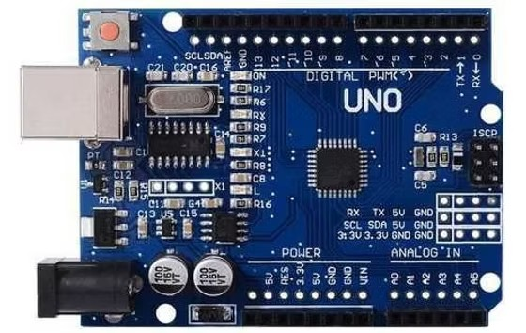
Simulation Diagram Reference
